Unit 2 My Schoolbag
Part B (2)
一、先填空，再连线。(15分)
1．p____n 三十
2．b____g 钢笔
3．p____nci____ 二十
4．twen____y 铅笔
5．th____ ____ty 包
二、火眼金睛，选一选。(20分)
( )1.________is in it?
A．What B．Where
C．Who
( )2.I have________pencilcases.
A．thirty one B．thirty five
C．thirtyfive
( )3.________storybooks do you have?
A．How many B．How much
C．What
( )4.What is________your bag?
A．to B．on C．in
三、根据提示完成句子。(15分)
1．Put your ________(橡皮)on your desk.
2．Put your ________(尺子)on your chair.
3．Put the ________(橘子)under your schoolbag.
四、想一想，选一选。(30分)
( )1.当你觉得书包太重时，你应说：
________
A．My schoolbag is too heavy.
B．This is my schoolbag.
( )2.当你想对帮助你的人表达感激之情时，你应说：________
A．You're welcome.
B．Thank you so much.
( )3.晚饭后，你想告诉妈妈你吃饱了，你应说：________
A．I am full.
B．I am tired.
五、你知道吗？(20分)
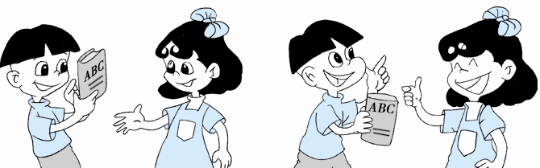
( )1.What are books made of?
A．Paper.
B．Water.
( )2.Who's the inventor(发明家) of paper?
A．Chinese people.
B．American people.

参考答案
